**space facts**

* An astronaut or cosmonaut is a person trained by a spaceflight program to lead, pilot or be a crew member of an expedition to [space](http://www.sciencekids.co.nz/sciencefacts/space.html) on a spacecraft.
* The "edge of space" is scientifically accepted to be 100 km (62 mi) above sea level at the 'Karman line'. As of June 2013, a total of 532 people representing 36 nations have been above the Karman Line and therefore have reached outer space.

The first person to reach space was Soviet, Yuri Gagarin, in 1961, on board the spacecraft Vostok 1, he orbited [Earth](http://www.sciencekids.co.nz/sciencefacts/earth.html) for 108 minutes.

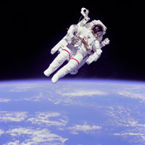**picture of the man in space searching**

The first woman in space was Soviet Valentina Tereshkova, in 1963. She orbited Earth for nearly 3 days aboard Vostok 6.

Russian, Sergei Krikalev, has been to space 6 times including on two ISS expeditions and has spent a total of 803 days, 9 hours and 39 minutes (or 2.2 years) in space, more than any other human who has ever lived (as at 2013).

* 12 men have walked on the [Moon](http://www.sciencekids.co.nz/sciencefacts/space/moon.html), two from each of the six different Apollo missions.
* Cosmonaut Alexei Leonov was the first person to carry out an extra-vehicular activity (EVA) or a "spacewalk", on March 18, 1965, on the Voskhod 2 mission.
* Cosmonaut Anatoly Solovyev holds the record for the most EVAs or spacewalks with 16, over a total of 82 hours and 22 minutes (as at 2013).

**Moon facts**

**The Moon is the Earth’s only natural satellite. A natural satellite is a space body that orbits a** [**planet**](http://www.sciencekids.co.nz/sciencefacts/planets.html)**, a planet like object or an** [**asteroid**](http://www.sciencekids.co.nz/sciencefacts/space/asteroids.html).

**It is the fifth largest moon in the** [**Solar System**](http://www.sciencekids.co.nz/sciencefacts/space/solarsystem.html)**. Learn more about the other** [**moons in the Solar System**](http://www.sciencekids.co.nz/sciencefacts/space/solarsystemmoons.html)**.**

**The average distance from the Moon to the Earth is 384403 kilometeres (238857 miles).**

**The Moon orbits the Earth every 27.3 days**.

Mons Huygens is the tallest mountain on the Moon, it is 4700 metres tall, just over half the height of Mt Everest (8848m).

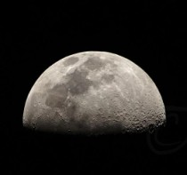

The Moon rotates on its axis in around the same length of time it takes to orbit the Earth. This means that from Earth we only ever see around 60% of its surface (50% at any one time).

The side that we can see from Earth is called the near side while the other side is called the far side (it is sometimes called the dark side despite the fact that it illuminated by the Sun just as much as the near side).

The effect of gravity is only about one fifth (17%) as strong on the surface of the Moon compared to the strength of gravity on the surface of the Earth.

The Soviet Union’s Luna program featured the first successful landing of an unmanned spacecraft on the surface of the Moon in 1966.

Planet facts

**Planets have fascinated scientists and humans in general for years after all we do live on one ourselves . By learning more about these amazing objects that orbit the same sun as Earth, we can learn more about our own planet.**

**The beauty of the planets found in our solar system is that they are so varied, with each one offering a new insight into everything from chemistry to geography phiscles**. 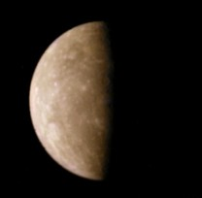merceury picture

**The surface of Mercury is very similar to our moon. It has a very barren, rocky surface covered with many craters.**

**Being so close to the Sun, the daytime temperature on Mercury is scorching - reaching over 400 Degrees Celsius.**

**At night however, without an atmosphere to hold the heat in, the temperatures plummet, dropping to -180 Degrees Celsius.**

**Mercury has a very low surface gravity.**

**Mercury has no atmosphere which means there is no wind or weather to speak of.**

**There is also no water on the surface of Mercury, it is possible however that there could be water underneath the surface.**

**Merceury was the hottest planet in the world.**

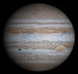**Jupiter**

**Jupiter is the fifth planet in order from the Sun and is about 483 million miles, or 777 million kilometres** [**from the Sun**](http://www.planetsforkids.org/star-sun.html)**.  Figure 1 shows the planets in order but the distances to the are not to scale.  The** [**Earth**](http://www.planetsforkids.org/planet-earth.html) **is much closer Sun than it is to Jupiter.**